Electero Damavand
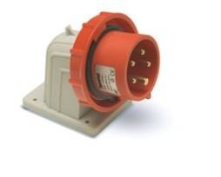 |  | 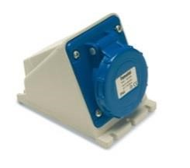 |  | 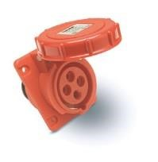 |  | 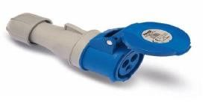 |  | 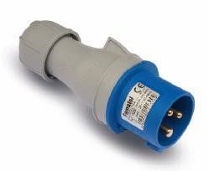 |  | Made In Spain
معکوس دیواری (نری) |  | دیواری (مادگی دیواری) |  | تابلویی ( مادگی توکار) |  | کانکتور سیار (مادگی)  امپر |  | پلاک سیار ( نری)  پین  ولتاژ |  | پین | ولتاژ | آمپر
IP67 | IP44 | IP67 | IP44 | IP67 | IP44 | IP67 | IP44 | IP67 | IP44
14150 | 13150 | 24190 | 23190 | 24130 | 23130 | 24100 | 23100 | 14100 | 13100 | 3 | 110 | 16
14151 | 13151 | 24191 | 23191 | 24131 | 23131 | 24101 | 23101 | 14101 | 13101 | 4
14250 | 13250 | 24290 | 23290 | 24230 | 23230 | 24200 | 23200 | 14200 | 13200 | 3 | 220
14251 | 13251 | 24291 | 23291 | 24231 | 23231 | 24201 | 23201 | 14201 | 13201 | 4
14252 | 13252 |  |  | 24232 | 23232 | 24202 | 23202 | 14202 | 13202 | 5  16
14350 | 13350 | 24390 | 23390 | 24330 | 23330 | 24300 | 23300 | 14300 | 13300 | 4 | 380
14351 | 13351 | 24391 | 23391 | 24331 | 23331 | 24301 | 23301 | 14301 | 13301 | 5
14450 | 13450 | 24490 | 23490 | 24430 | 23430 | 24400 | 23400 | 14400 | 13400 | 4 | 500
14451 | 13451 | 24491 | 23491 | 24431 | 23431 | 24401 | 23401 | 14401 | 13401 | 5
14152 | 13152 | 24192 | 23192 | 24132 | 23132 | 24102 | 23102 | 14102 | 13102 | 3 | 110 | 32
14153 | 13153 | 24193 | 23193 | 24133 | 23133 | 24103 | 23103 | 14103 | 13103 | 4
14253 | 13253 | 24292 | 23292 | 24233 | 23233 | 24203 | 23203 | 14203 | 13203 | 3 | 220
14254 | 13254 | 24293 | 23293 | 24234 | 23234 | 24204 | 23204 | 14204 | 13204 | 4  32
14352 | 13352 | 24392 | 23392 | 24332 | 23332 | 24302 | 23302 | 14302 | 13302 | 4 | 380
14353 | 13353 | 24393 | 23393 | 24333 | 23333 | 24303 | 23303 | 14303 | 13303 | 5
14452 | 13452 | 24492 | 23492 | 24432 | 23432 | 24402 | 23402 | 14402 | 13402 | 4 | 500
14453 | 13453 | 24493 | 23493 | 24433 | 23433 | 24403 | 23403 | 14403 | 13403 | 5
 |  |  |  | 24235 |  | 24205 |  | 14205 |  | 3 | 220 | 63
 |  |  |  | 24236 |  | 24206 |  | 14206 |  | 4
14354 |  | 24394 |  | 24334 |  | 24304 |  | 14304 |  | 4 | 380
14355 |  | 24395 |  | 24335 |  | 24305 |  | 14305 |  | 5  63
14865 |  | 24496 |  | 24437 |  | 24404 |  | 14404 |  | 4 | 500
14866 |  | 24497 |  | 24438 |  | 24405 |  | 14405 |  | 5
 |  | 24396 |  | 24337 |  | 24306 |  | 14306 |  | 4 | 380 | 125
 |  | 24397 |  | 24338 |  | 24307 |  | 14307 |  | 5  125
14867 |  | 24498 |  | 24439 |  | 24406 |  | 14406 |  | 4 | 500
14868 |  | 24499 |  | 24440 |  | 24407 |  | 14407 |  | 5
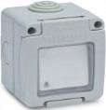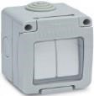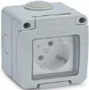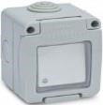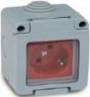
821,000 686,000 677,000 709,000 775,000
19072 19044 19068 19074 19073
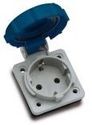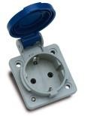
13950 13960
560,000 952,000
الکترو دماوند  07132348943  07132348944  09173151621 |  |  |  | 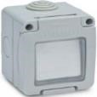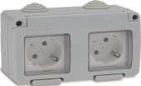  19071 19032

